**Activity 5.2 - Building a Switch and Router Network ON-CAMPUS version**

# Topology

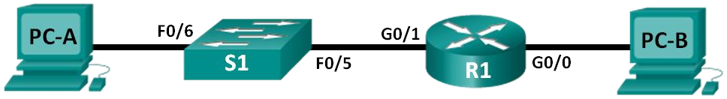

# Addressing Table



|  |  |  |  |  |
| --- | --- | --- | --- | --- |
| **Device** | **Interface** | **IP Address** | **Subnet Mask** | **Default Gateway** |
| R1 | G0/0 | 192.168.0.1 | 255.255.255.0 | N/A |
| G0/1 | 192.168.1.1 | 255.255.255.0 | N/A |
| PC-A | NIC | 192.168.1.3 | 255.255.255.0 | 192.168.1.1 |
| PC-B | NIC | 192.168.0.3 | 255.255.255.0 | 192.168.0.1 |
| S1 | VLAN 1 | 192.168.1.11 | 255.255.255.0 | 192.168.1.1 |

# Objectives

**Part 1: Set Up the Topology and Initialize Devices**

**Part 2: Configure Devices and Verify Connectivity Part 3: Display Device Information**

# Background / Scenario

This is a comprehensive lab to review previously covered IOS commands. In this lab, you will cable the equipment as shown in the topology diagram. You will then configure the devices to match the addressing table. After the configurations have been saved, you will verify your configurations by testing for network connectivity.

After the devices have been configured and network connectivity has been verified, you will use IOS commands to retrieve information from the devices to answer questions about your network equipment.

This lab provides minimal assistance with the actual commands necessary to configure the router. Test your knowledge by trying to configure the devices without referring to the content or previous activities.

# Required Resources

* 2 PCs
* 1 switch
* 1 router

# Part 1: Set Up Topology and Initialize Devices

**Step 1: Cable the network as shown in the topology.**

a. Create and cable the devices shown in the topology diagram.

# Part 2: Configure Devices and Verify Connectivity

In Part 2, you will set up the network topology and configure basic settings, such as the interface IP addresses, device access, and passwords. Refer to the Topology and Addressing Table at the beginning of this lab for device names and address information.

**Step 1: Assign static IP information to the PC interfaces.**

1. Configure the IP address, subnet mask, and default gateway settings on PC-A.
2. Configure the IP address, subnet mask, and default gateway settings on PC-B.
3. Ping PC-B from a command prompt window on PC-A.

**Reflection:**

Why were the pings not successful?

**Because the router is not configured yet hence the packet cannot be forwarded.**

What is a default Gateway?

**The ip where the switch can forward the packet to communicate with other devices on a different network.**

**Step 2: Configure the switch:**

Configure the switch as per the standard configuration discussed in previous labs:

* 1. Correct device names as per the topology
  2. DNS lookup turned off
  3. IP address as listed in Addressing Table
  4. Configure the default gateway for the Switch:

The command for this is:

ip default-gateway (IP address) and can be entered from Global Configuration mode.

* 1. Clear text passwords encrypted.
  2. **cisco** as the console and vty passwords with login and synchronous logging enabled
  3. **class** as the privileged EXEC password
  4. Banner that warns anyone accessing the device that unauthorized access is prohibited. With the following text:

**Unauthorised access of this device is strictly prohibited.**

**Step 3: Configure the router.**

1. Console into the router from one of the PCs and enable privileged EXEC mode.

You may be prompted with the following question:

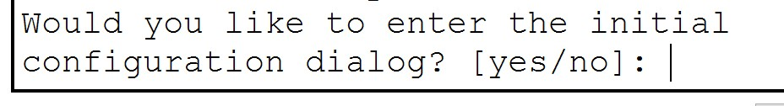

**Type ‘no’** and ‘enter’ to skip the automated configuration process, we will configure the router manually.

1. Enter configuration mode.
2. Assign a device name to the router.
3. Disable DNS lookup to prevent the router from attempting to translate incorrectly entered commands as though they were host names.
4. Assign **class** as the privileged EXEC encrypted password.
5. Assign **cisco** as the console password with login and synchronous logging enabled.
6. Assign **cisco** as the VTY password with login and synchronous logging enabled. Verify the number of vty lines that are on the router.
7. Encrypt the clear text passwords.
8. Create a banner that warns anyone accessing the device:

**Unauthorised access of this device is strictly prohibited.**

1. Configure and activate both interfaces on the router.

To assign IP addresses to the interfaces on Routers these commands will be used

Router(config)#interface (*interface ID*)

Router(config-if)#ip address (*ipAddress subnetmask*)

Router(config-if)#no shutdown

Assign *IP* addresses to both interfaces on the Router as per the addressing table.

1. Ping PC-B from a command prompt window on PC-A.

**Reflection:**

Were the pings successful? Why?

**Yes.**

**Because the router was now configured.**

**And the packets could be sent now.**

# Part 3: Display Device Information

In Part 3, you will use **show** commands to retrieve information from the router and switch. This will help you to become familiar with the various ways to obtain information about the configuration of a device which can be useful when troubleshooting.

**Step 1: Retrieve hardware and software information from the network devices.**

1. Use the **show version** command to answer the following questions about the router.

What is the name of the IOS image that the router is running?

____________________________________________________________________________________ How much DRAM memory does the router have?

____________________________________________________________________________________

____________________________________________________________________________________ How much NVRAM memory does the router have?

____________________________________________________________________________________ How much Flash memory does the router have?

____________________________________________________________________________________

1. Use the **show version** command to answer the following questions about the switch.

What is the name of the IOS image that the switch is running?

____________________________________________________________________________________ How much dynamic random access memory (DRAM) does the switch have?

____________________________________________________________________________________ How much nonvolatile random-access memory (NVRAM) does the switch have?

____________________________________________________________________________________ What is the model number of the switch?

____________________________________________________________________________________

**Step 2: Display interface information on the router.**

Use the **show interface g0/1** to answer the following questions.

What is the operational status of the G0/1 interface?

_______________________________________________________________________________________ What is the Media Access Control (MAC) address of the G0/1 interface?

_______________________________________________________________________________________ How is the Internet address displayed in this command?

**Step 3: Display a summary list of the interfaces on the router and switch.**

There are several commands that can be used to verify an interface configuration. One of the most useful of these is the **show ip interface brief** command. The command output displays a summary list of the interfaces on the device and provides immediate feedback to the status of each interface. a. Enter the **show ip interface brief** command on the router.

R1# **show ip interface brief**

b. Enter the **show ip interface brief** command on the switch.

Switch# **show ip interface brief**

***Questions:***

Issue Show Run on Switch and Router and compare Interfaces on both? What are the differences? What are the characteristics of them?

_______________________________________________________________________________________ _______________________________________________________________________________________

**Reflection:**

1. If the G0/1 interface showed administratively down, what interface configuration command would you use to turn the interface up?

_______________________________________________________________________________________

1. What would happen if you had incorrectly configured interface G0/1 on the router with an IP address of 192.168.1.2?

_______________________________________________________________________________________

_______________________________________________________________________________________ 3. What would happen if you did not put a default gateway on the switch?

_______________________________________________________________________________________

Would you be able to ping to PC-B from PC-A?

_______________________________________________________________________________________

Would you be able to ping from S1 from PC-A?

_______________________________________________________________________________________

**Note:** You can use the ping command from the CLI of the switch (if you are not in configuration mode) in the same way that you can ping from the command line of a PC.

Why?

_______________________________________________________________________________________

Would you be able to ping from S1 from PC-B?

_______________________________________________________________________________________ Why?

_______________________________________________________________________________________